**Java Breaker: A Modern Twist to Classic Brick Breaker Game**

**1.Introduction:**

**1.1 Background**

The Brick Breaker game, originating from the arcade era, holds a special place in the hearts of gamers worldwide. Its simple yet addictive gameplay, where players use a paddle to bounce a ball and break bricks, has endured through the years. The project introduces a digital adaptation of this classic game, implemented in Java. The goal is to preserve the nostalgic appeal of the original while incorporating modern programming principles and techniques.

**1.2 Purpose**

The primary objective of this project is twofold. Firstly, it aims to deliver a delightful gaming experience, allowing players to relive the excitement of the Brick Breaker game in a digital format. Secondly, it serves as an educational initiative, providing a practical learning opportunity for Java developers interested in game development. By dissecting the code and understanding the mechanics behind a simple yet engaging game, developers can enhance their programming skills and gain valuable insights into game design principles.

**1.3 Scope**

The project's scope encompasses the implementation of key gaming elements that constitute the essence of Brick Breaker. These elements include the dynamic movement of the paddle, realistic ball dynamics, accurate brick collision detection, scoring mechanisms, and effective game state management. The focus is on creating a well-rounded gaming experience that captures the spirit of the original arcade game.

**1.4 Project Overview**

The architecture of the project revolves around three main classes: **Main11**, **Gameplay**, and **MapGenerator**. These classes synergize to form the backbone of the digital Brick Breaker game. The **Main11** class serves as the entry point, initializing the game environment. The **Gameplay** class manages the core logic and rendering, while the **MapGenerator** class handles the creation and rendering of the brick layout. Together, these classes create an interactive and enjoyable gaming experience.

**2. Project Structure**

**2.1 Main11 Class**

The **Main11** class acts as the entry point for the application, initializing the main frame (**JFrame**) and the **Gameplay** object. It plays a pivotal role in setting up key properties of the frame and adding the **Gameplay** object for display.

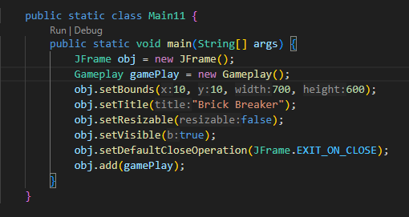

**2.2 Gameplay Class**

The **Gameplay** class, extending **JPanel**, implements the game's logic and rendering. It is the central class responsible for managing the game state, user input, and visual representation.

**2.2.1 Game Initialization**

Within the **Gameplay** class, the initial game state is established. This includes setting up the paddle, ball, and brick map. A timer is initialized for game events, and a **MapGenerator** object is created.

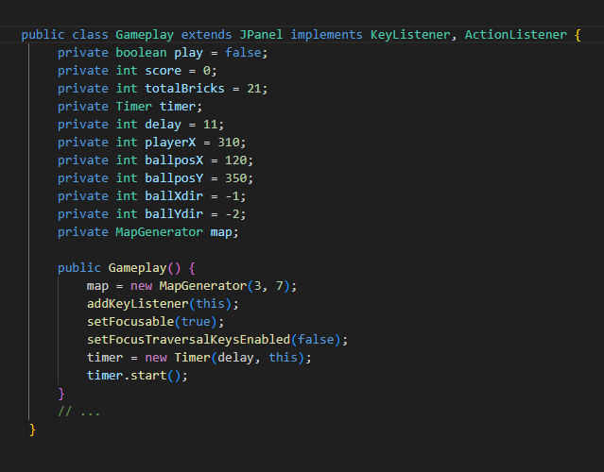

**2.2.2 Rendering**

The **paint** method in **Gameplay** handles rendering by drawing various game components such as the background, paddle, ball, bricks, and score.

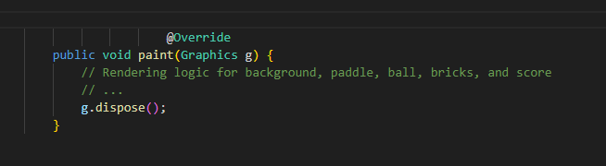

**2.2.3 User Input Handling**

The class implements **KeyListener** to detect user input for paddle movement (left and right arrow keys) and game restart (Enter key).

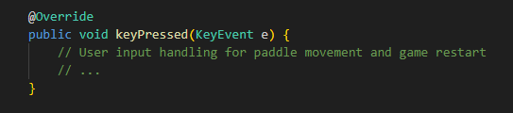

**2.2.4 Collision Detection**

Accurate collision detection is implemented between the ball, paddle, and bricks, influencing the ball's trajectory based on these collisions

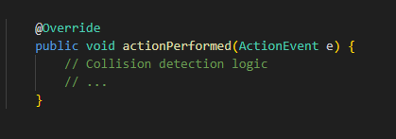

**2.2.5 Game State Management**

**Gameplay** manages the game state, determining playability, updating the score, and handling conditions for winning or losing.

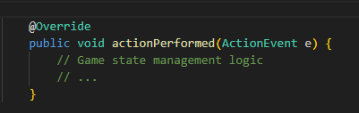

**2.3 MapGenerator Class**

The **MapGenerator** class is responsible for creating and rendering the brick map. It initializes a 2D array representing the bricks and provides methods to draw and modify individual bricks.

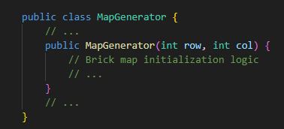

**3. Key Functionalities**

**3.1 Paddle Movement**

Paddle movement is a fundamental aspect of the game, allowing players to control the horizontal position of the paddle using the left and right arrow keys. The responsive and intuitive controls provide players with the means to strategically interact with the ball and prevent it from passing the paddle.

**3.2 Ball Dynamics**

The ball exhibits dynamic behavior as it traverses the screen. Its movement is governed by algorithms that dictate its trajectory, enabling it to bounce off the paddle and react dynamically to collisions with bricks. This dynamic ball behavior adds an element of unpredictability to the game, challenging players to anticipate and react swiftly.

**3.3 Collision Detection**

Accurate collision detection is a crucial component of the gameplay. The system precisely detects collisions between the ball, paddle, and individual bricks. Upon collision, the game adjusts the ball's trajectory based on the point of impact, ensuring realistic and engaging interactions between game elements.

**3.4 Scoring**

The scoring mechanism enhances the competitive aspect of the game. Players earn points for each successfully destroyed brick, contributing to their overall score. This incentivizes efficient brick destruction strategies and adds a layer of achievement and progression to the gaming experience.

**3.5 Game Over and Restart**

The game provides clear conditions for both victory and defeat. If the ball passes the bottom boundary, indicating a missed opportunity, or when all bricks are successfully destroyed, the game concludes. In the event of a game over, players have the option to restart the game promptly by pressing the Enter key. This streamlined restart process encourages players to quickly re-engage with the game, promoting a seamless and enjoyable gaming experience.

**4. Code Details**

**4.1 Encapsulation**

The code demonstrates encapsulation by encapsulating related functionalities within methods and objects. For example, the **Gameplay** class encapsulates the game logic, rendering, and user input handling. However, further enhancements could be made to ensure strict encapsulation, such as reviewing access modifiers and encapsulating class attributes through getter and setter methods.

**4.2 Code Comments**

The presence of comments within the code is commendable, as it aids in clarifying complex logic and documenting key functionalities. However, to adhere to best practices, a more comprehensive and structured approach to commenting could be implemented. This includes providing high-level comments for classes and methods, as well as inline comments for intricate algorithms.

**4.3 Code Refactoring**

Opportunities for code refactoring exist to improve readability and maintainability. Identifying and refactoring repetitive code segments, consolidating similar functionalities, and adhering to design patterns can contribute to more efficient and elegant code. Refactoring could focus on breaking down complex methods into smaller, more modular functions and enhancing the overall structure of the codebase.

**4.4 Error Handling**

While the current implementation addresses common scenarios, incorporating comprehensive error handling mechanisms is essential to enhance the robustness of the application. This could involve implementing try-catch blocks to handle exceptions, providing meaningful error messages, and ensuring graceful degradation in the face of unexpected issues.

**4.5 Code Formatting**

Consistent code formatting based on established standards is crucial for better readability and conformity to coding conventions. Ensuring that the code follows a consistent style, including indentation, spacing, and naming conventions, contributes to a professional and maintainable codebase. Consider using code formatting tools or IDE features to automate and enforce consistent formatting throughout the project.

**5. Gameplay Class Deep Dive**

**5.1 Timer Usage**

The Gameplay class utilizes the Timer class to orchestrate game events and updates. The timer ensures that the game state is regularly refreshed, enabling smooth animations and dynamic gameplay. A deeper analysis of timer usage involves evaluating the timer's interval, exploring potential adjustments for optimal performance, and considering alternatives such as a game loop mechanism. Fine-tuning the timer can have a significant impact on the game's responsiveness and overall user experience.

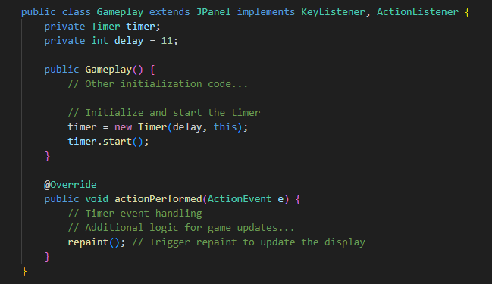

**5.2 Graphics Rendering**

Graphics rendering in the Gameplay class is facilitated through the Graphics class. A thorough examination of the rendering process includes analyzing how various game components are drawn, exploring the order of rendering, and assessing the efficiency of rendering algorithms. Optimizations in graphics rendering can contribute to enhanced frame rates and improved visual fidelity. Additionally, exploring advanced rendering techniques or leveraging hardware acceleration may further elevate the quality of the game's graphics

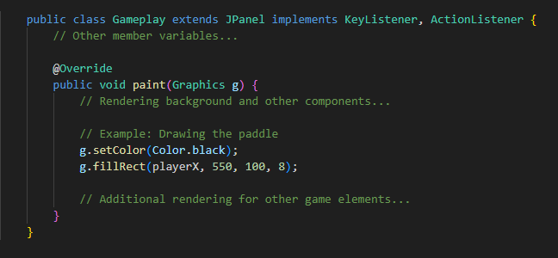

**5.3 Player Input Handling**

User input handling is a critical aspect of the Gameplay class, responsible for interpreting player actions. A detailed exploration of how key events are processed, the responsiveness of controls, and potential input-related enhancements can be valuable. Considerations may include input buffering, input validation, and responsiveness adjustments to provide a more satisfying and intuitive gameplay experience.

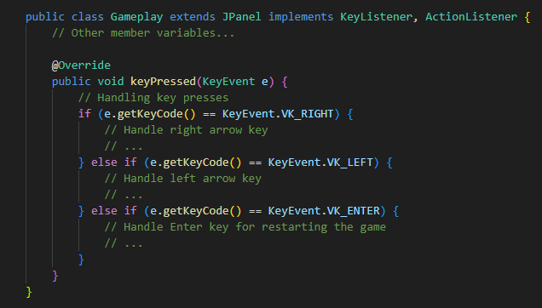

**5.4 Brick Map Interaction**

The interaction between the ball and the brick map is a key gameplay element. Examining how the Gameplay class manages the generation, rendering, and modification of the brick map sheds light on collision detection algorithms. A detailed analysis of collision handling, including the determination of collision points and the subsequent adjustments to the ball's trajectory, can provide insights into the precision and realism of the game mechanics.

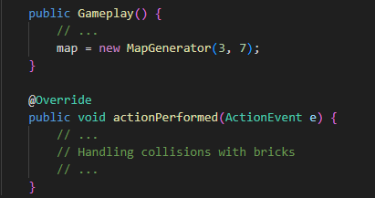

**5.5 Ball Movement and Collisions**

The dynamics of ball movement and collision detection are fundamental to the Gameplay class. Delving into the algorithms governing ball movement, collision detection with the paddle, and interactions with individual bricks reveals the intricacies of the game's physics. Analyzing these aspects can uncover opportunities for fine-tuning, optimizing performance, and potentially introducing advanced physics simulations for a more engaging gaming experience.

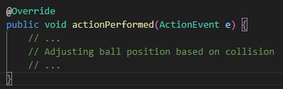

This deep dive into the Gameplay class aims to provide a comprehensive understanding of its core functionalities, paving the way for potential optimizations, enhancements, and refinements in subsequent development phases.

**6. MapGenerator Class Deep Dive**

**6.1 Brick Map Initialization**

The initialization of the brick map in the MapGenerator class is pivotal. An examination of how the map is initialized and potential variations could be explored. The method by which the 2D array representing the bricks is set up establishes the foundation for the entire brick layout. Exploring variations in brick patterns, introducing randomization, or implementing custom initialization strategies could add diversity to the game's levels.

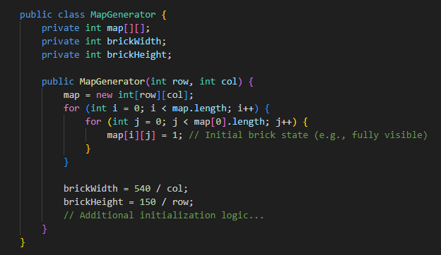

**6.2 Drawing Bricks**

The draw method in MapGenerator is responsible for visually rendering the bricks. A deep dive into the drawing process and potential graphical enhancements could be considered. Analyzing how individual bricks are drawn, exploring variations in brick appearance, or incorporating dynamic visual elements can contribute to a more engaging and visually appealing gaming experience.

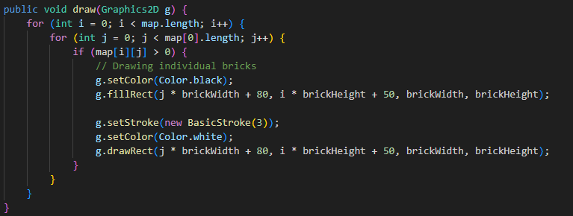

**6.3 Brick Value Modification**

Understanding how the value of individual bricks is modified during gameplay provides insights into the process of brick removal. The setBrickValue method, which updates the state of a specific brick, is critical for managing the state of the brick map. Exploring variations in brick behavior, such as introducing different types of bricks with varying durability or incorporating power-ups, could add depth to the gameplay.

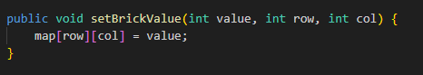

**7. Features**

**7.1 Core Gameplay Features**

**7.1.1 Paddle Movement**

* Intuitive and responsive controls for horizontal paddle movement.
* Player control using left and right arrow keys.

**7.1.2 Dynamic Ball Movement**

* Dynamic movement of the ball across the screen.
* Realistic bouncing off the paddle and dynamic reactions to brick collisions.

**7.1.3 Precise Collision Detection**

* Accurate collision detection system.
* Precise interactions between the ball, paddle, and individual bricks.

**7.1.4 Scoring Mechanism**

* Point system for efficient brick destruction.
* Continuous scoring contributing to the player's overall score.

**7.1.5 Game State Management**

* Effective game state management for a seamless gaming experience.
* Determination of playability, score updates, and handling of win/loss conditions.

**8.Sample Output:**

**i)**

On initialising the game a popup is appears which starts the game..

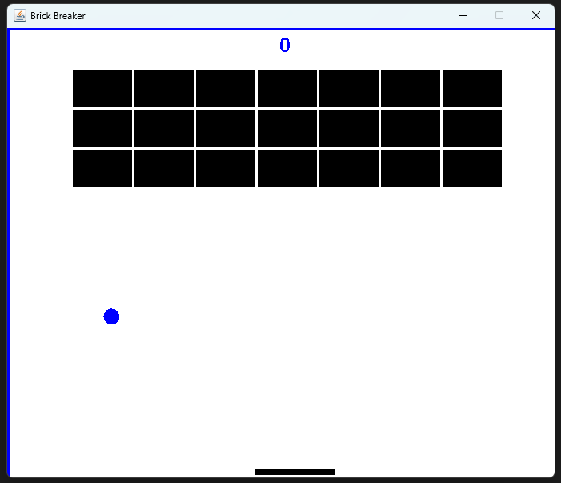

**ii)**

When the ball goes out of bounds, signaling a missed opportunity, the game gracefully displays the player's score and prompts for a quick restart, ensuring a seamless transition for the player to re-engage with the gameplay

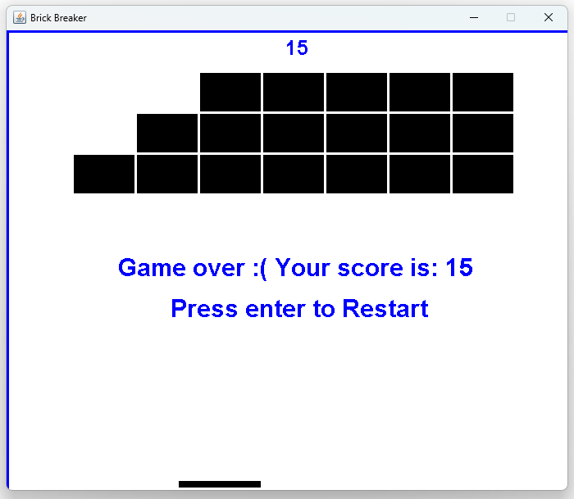

**iii)**

When the game is totally Completed…..

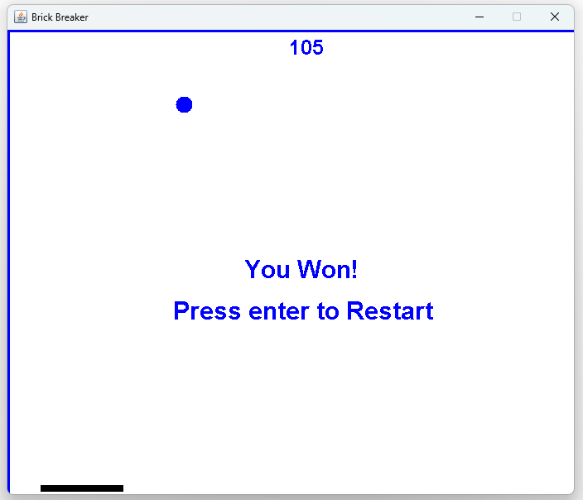

**##Souce Code:**

**#Main11.java**

import javax.swing.JFrame;

public class Main11 {

    public static void main(String[] args) {

        JFrame obj = new JFrame();

        Gameplay gamePlay = new Gameplay();

        obj.setBounds(10, 10, 700, 600);

        obj.setTitle("Brick Breaker");

        obj.setResizable(false);

        obj.setVisible(true);

        obj.setDefaultCloseOperation(JFrame.EXIT_ON_CLOSE);

        obj.add(gamePlay);

    }

}

**##MapGenerator.java**

import java.awt.BasicStroke;

import java.awt.Color;

import java.awt.Graphics2D;

public class MapGenerator {

    public int map[][];

    public int brickWidth;

    public int brickHeight;

    public MapGenerator(int row, int col) {

        map = new int[row][col];

        for(int i = 0; i < map.length; i++) {

            for(int j=0; j< map[0].length; j++) {

                map[i][j] = 1;

            }

        }

        brickWidth = 540/col;

        brickHeight = 150/row;

    }

    public void draw(Graphics2D g) {

        for(int i = 0; i < map.length; i++) {

            for(int j=0; j< map[0].length; j++) {

                if(map[i][j] > 0) {

                    g.setColor(Color.black);

                    g.fillRect(j * brickWidth + 80, i * brickHeight + 50, brickWidth, brickHeight);

                    g.setStroke(new BasicStroke(3));

                    g.setColor(Color.white);

                    g.drawRect(j * brickWidth + 80, i * brickHeight + 50, brickWidth, brickHeight);

                }

            }

        }

    }

    public void setBrickValue(int value, int row, int col) {

        map[row][col] = value;

    }

}

**##Gameplay.java**

import java.awt.Color;

import java.awt.Font;

import java.awt.Graphics;

import java.awt.Graphics2D;

import java.awt.Rectangle;

import java.awt.event.ActionEvent;

import java.awt.event.ActionListener;

import java.awt.event.KeyEvent;

import java.awt.event.KeyListener;

import javax.swing.Timer;

import javax.swing.JPanel;

public class Gameplay extends JPanel implements KeyListener, ActionListener{

    private boolean play = false;

    private int score = 0;

    private int totalBricks = 21;

    private Timer timer;

    private int delay = 11;

    private int playerX = 310;

    private int ballposX = 120;

    private int ballposY = 350;

    private int ballXdir = -1;

    private int ballYdir = -2;

    private MapGenerator map;

    public Gameplay() {

        map = new MapGenerator(3, 7);

        addKeyListener(this);

        setFocusable(true);

        setFocusTraversalKeysEnabled(false);

        timer = new Timer(delay, this);

        timer.start();

    }

    public void paint(Graphics g) {

        // background

        g.setColor(Color.white);

        g.fillRect(1,1, 691, 592);

        // drawing map

        map.draw((Graphics2D)g);

        // borders

        g.setColor(Color.blue);

        g.fillRect(0, 0, 3, 592);

        g.fillRect(0, 0, 692, 3);

        g.fillRect(691, 0, 3, 592);

        // paddle

        g.setColor(Color.black);

        g.fillRect(playerX, 550, 100, 8);

        // scores

        g.setColor(Color.blue);

        g.setFont(new Font("helvetica", Font.BOLD, 25));

        g.drawString(""+score,340,30);

        // ball

        g.setColor(Color.blue);

        g.fillOval(ballposX, ballposY, 20, 20);

        if(totalBricks <= 0) {

            play = false;

            ballXdir = 0;

            ballYdir = 0;

            g.setColor(Color.BLUE);

            g.setFont(new Font("helvetica", Font.BOLD, 30));

            g.drawString("You Won!" ,286 ,300);

            g.setFont(new Font("helvetica", Font.BOLD, 30));

            g.drawString("Press enter to Restart" ,200 ,350);

        }

        if(ballposY > 570) {

            play = false;

            ballXdir = 0;

            ballYdir = 0;

            g.setColor(Color.BLUE);

            g.setFont(new Font("helvetica", Font.BOLD, 30));

            g.drawString("Game over :( Your score is: " +score ,136 ,300);

            g.setFont(new Font("helvetica", Font.BOLD, 30));

            g.drawString("Press enter to Restart" ,200 ,350);

        }

        g.dispose();

    }

    @Override

    public void actionPerformed(ActionEvent e) {

        timer.start();

        if(play) {

            if(new Rectangle(ballposX, ballposY, 20, 20).intersects(new Rectangle(playerX, 550, 100, 8))) {

                ballYdir = -ballYdir;

        }

            A: for(int i = 0; i<map.map.length; i++) {

                for(int j = 0; j<map.map[0].length; j++) {

                    if(map.map[i][j] > 0) {

                        int brickX = j* map.brickWidth + 80;

                        int brickY = i* map.brickHeight +50;

                        int brickWidth = map.brickWidth;

                        int brickHeight = map.brickHeight;

                        Rectangle rect = new Rectangle(brickX, brickY, brickWidth, brickHeight);

                        Rectangle ballRect = new Rectangle(ballposX, ballposY, 20, 20);

                        Rectangle  brickRect = rect;

                        if(ballRect.intersects(brickRect)) {

                            map.setBrickValue(0, i, j);

                            totalBricks--;

                            score += 5;

                            if(ballposX + 19 <= brickRect.x || ballposX + 1 >= brickRect.x + brickRect.width) {

                                ballXdir = - ballXdir;

                            } else {

                                ballYdir = -ballYdir;

                            }

                            break A;

                        }

                    }

                }

            }

            ballposX += ballXdir;

            ballposY += ballYdir;

            if(ballposX < 0) {

                ballXdir = -ballXdir;

            }

            if(ballposY < 0) {

                ballYdir = -ballYdir;

            }

            if(ballposX > 670) {

                ballXdir = -ballXdir;

            }

        }

        repaint();

    }

    @Override

    public void keyTyped(KeyEvent e) {

    }

    @Override

    public void keyPressed(KeyEvent e) {

        if(e.getKeyCode() == KeyEvent.VK_RIGHT) {

            if(playerX >=600) {

                playerX = 600;}

            else {

                moveRight();

            }

        }

        if(e.getKeyCode() == KeyEvent.VK_LEFT) {

            if(playerX < 10) {

                playerX = 10;}

            else {

                moveLeft();

            }

        }

        if(e.getKeyCode() == KeyEvent.VK_ENTER) {

            if(!play) {

                play = true;

                ballposX = 120;

                ballposY = 350;

                ballXdir = -1;

                ballYdir = -2;

                playerX = 310;

                score = 0;

                totalBricks = 21;

                map = new MapGenerator (3, 7);

                repaint();

            }

        }

    }

    public void moveRight() {

        play = true;

        playerX+=20;

    }

    public void moveLeft() {

        play = true;

        playerX-=20;

    }

    @Override

    public void keyReleased(KeyEvent e) {

        }

}

**9.Conclusion:**

**9.1 Project Summary**

The Brick Breaker game, implemented in Java, provides an engaging and nostalgic gaming experience. The project successfully captures the essence of the classic arcade game while incorporating modern programming principles.

**9.2 Achievements**

The project has successfully implemented key gaming functionalities, including paddle movement, ball dynamics, collision detection, scoring, and game state management.

**9.3 Future Development Prospects**

The project offers opportunities for future development, including code optimization, enhanced features, and additional levels. The robust foundation laid by the current implementation allows for continued expansion and improvement.